**Day-1**

>mysql -u root –p //u= username p=password.

>show databases; //lists the databases.

>use surya_project; // user defined database.

**ER DIAGRAM**:

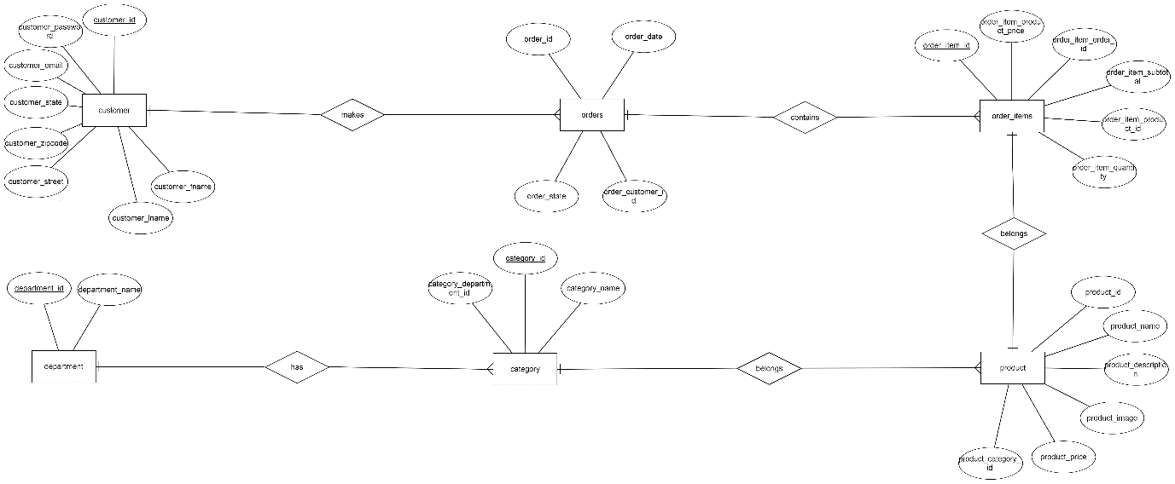

**INDENTIFYING RELATIONSHIP**

**CUSTOMER table:**

Primary key : customer_id

Foreign key : none

References Table :none

//main table

**ORDERS table:**

Primary key : order_id

Foreign key : order_customer-id

References Table : CUSTOMER

**ORDER_ITEM table:**

Primary key : order_item_id

Foreign key :order_item_order_id,order_item_product_id

References Table : ORDERS,PRODUCT

**PRODUCT table:**

Primary key : product_id

Foreign key : product_category_id

References Table : CATEGORIES

**CATEGORIES:**

Primary key : Category_name

Foreign key : category_department_id

References Table : DEPARTMENT

**DEPARTMENT:**

Primary key : department_id

Foreign key : none

References Table :none

**Creating tables in mysql:**

1)>create table customers(customer_id int auto_increment not null primary key,customer_fname varchar(45) not null,customer_lname varchar(45) not null,customer_email varchar(45) not null,customer_password varchar(45) not null,customer_street varchar(45) not null,customer_city varchar(45) not null,customer_state varchar(45) not null,customer_zipcode varchar(45) not null);

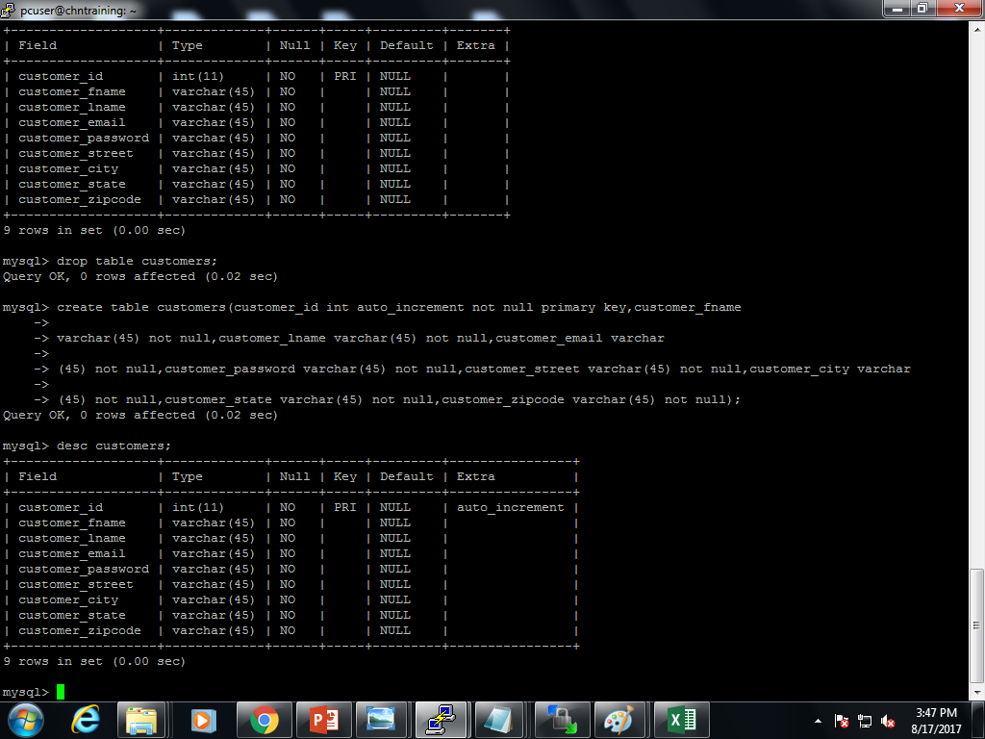

> load data local infile '/home/pcuser/surya/project/customer.csv' into table surya_project.customers fields terminated by ',' lines terminated by '\n';

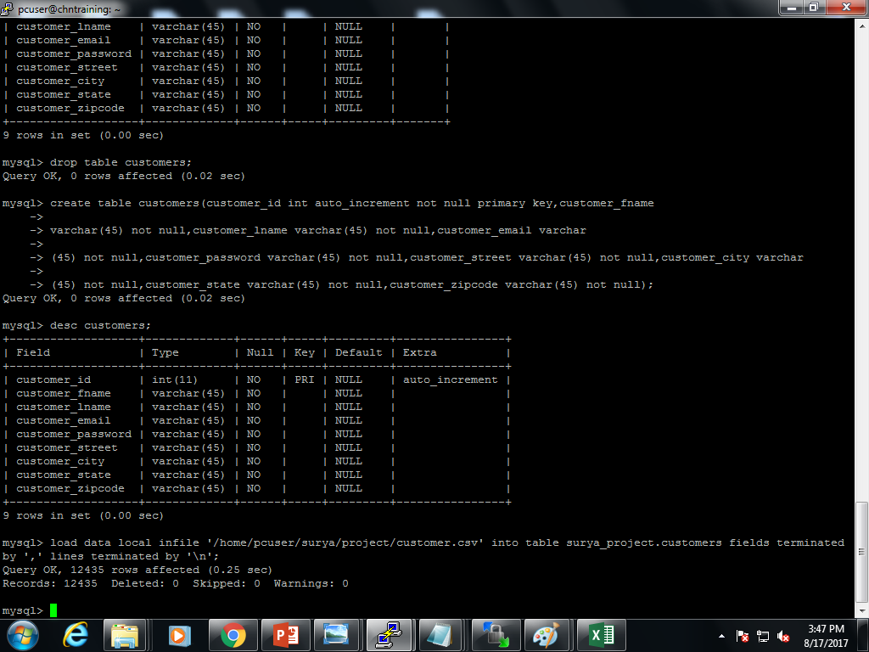

Select * from customers;

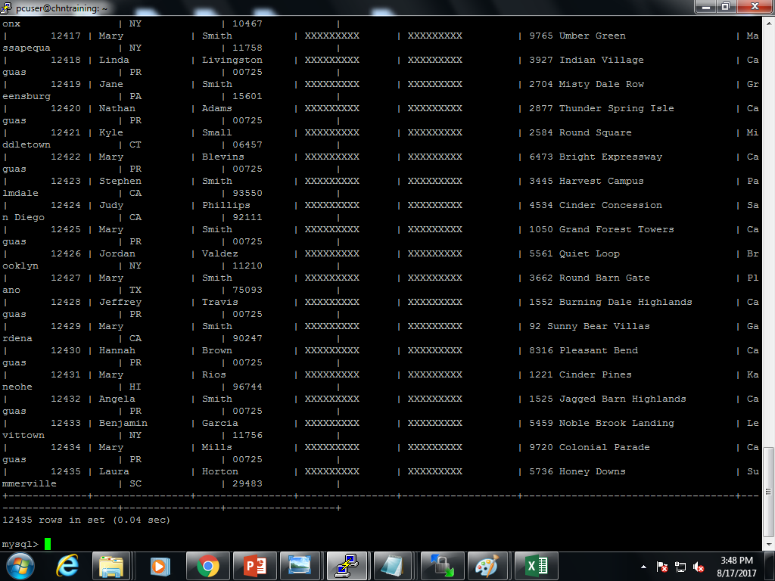

//supposed to be tried in hive because of complex datatype.

//implemented in mysql until discovered that it had to be done in hive,because mysql doesn’t support complex datatypes.

**//tried json datatype in mysql:**

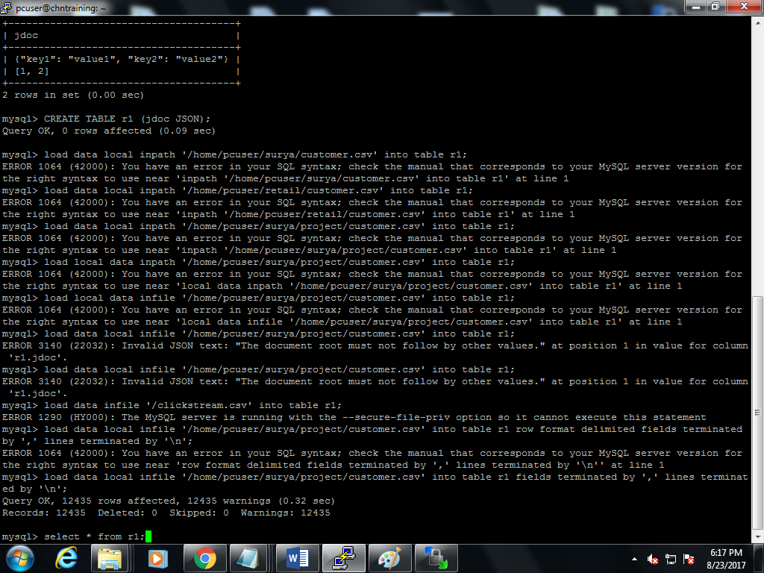



>Select * from r1;

>desc r1;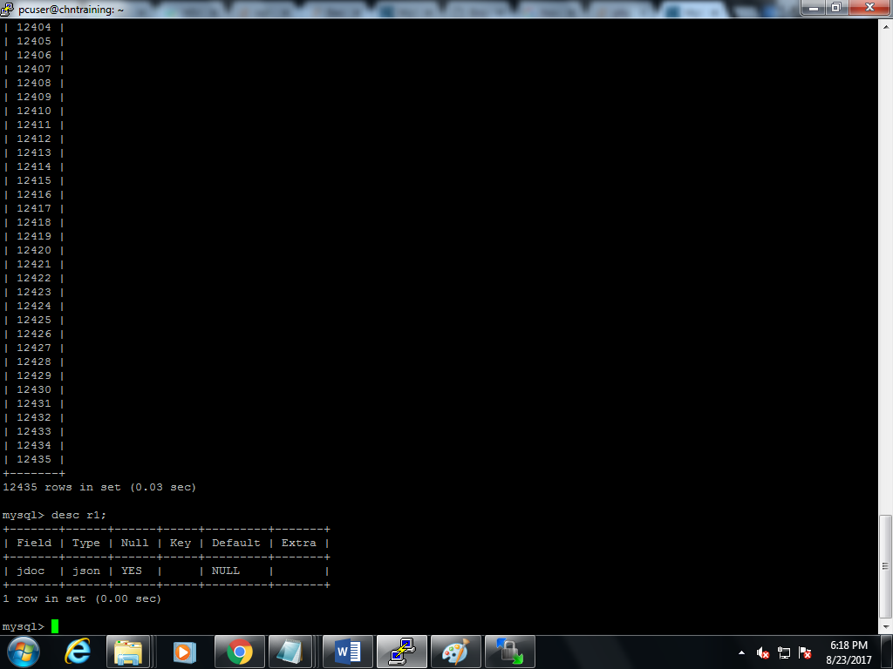

Only the customer_id is fetched thus the last custmomer_id =12435.

2) >create table category (category_id int(11) auto_increment not null primary key,category_department_id int(11),category_name varchar(45));

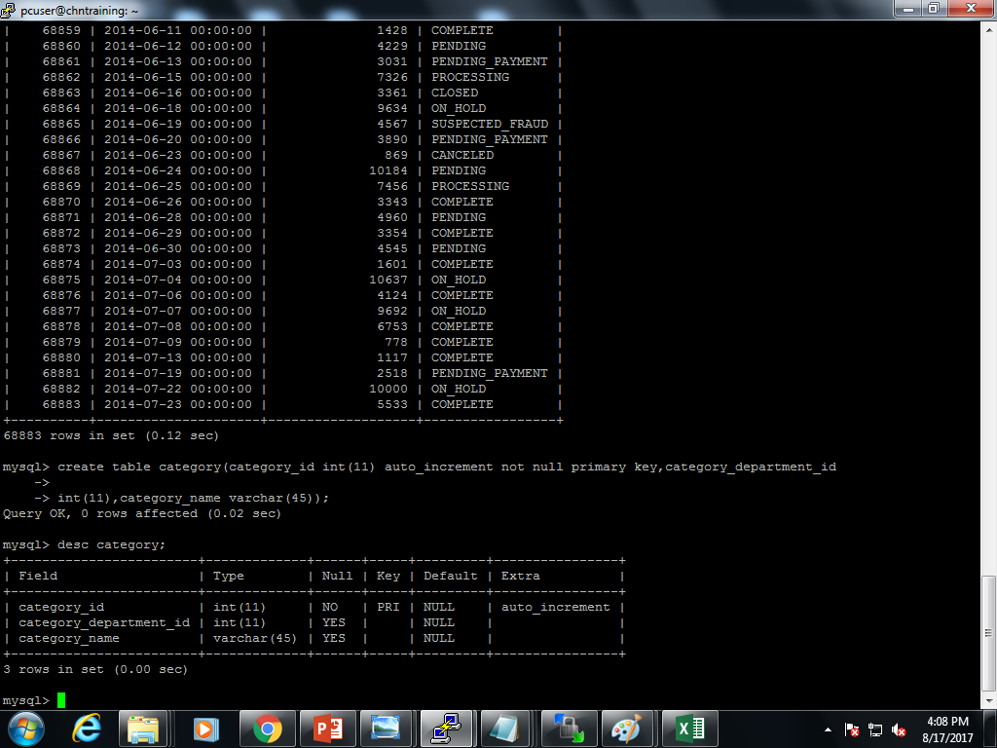

>load data local infile '/home/pcuser/surya/project/categories.csv' into table surya_project.category fields terminated by ',' lines terminated by '\n';

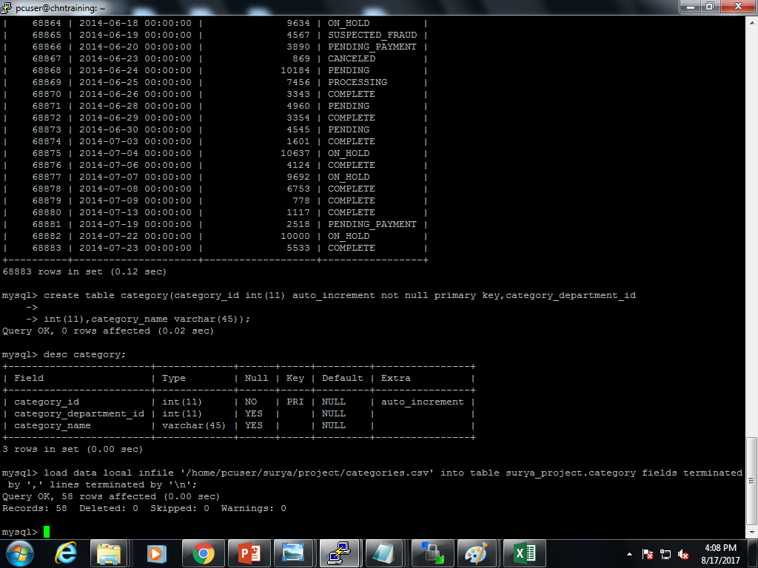

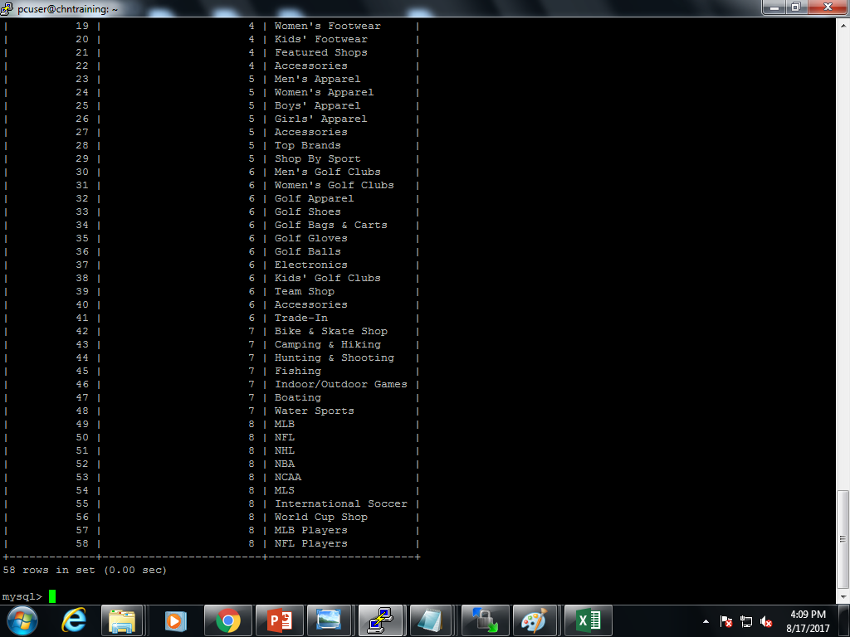

>select * from category;

3) Create table orders (order_id int(11) auto_increment not null primary key,order_date datetime not null,order_customer_id int(11) not null, order_status varchar(45) not null); 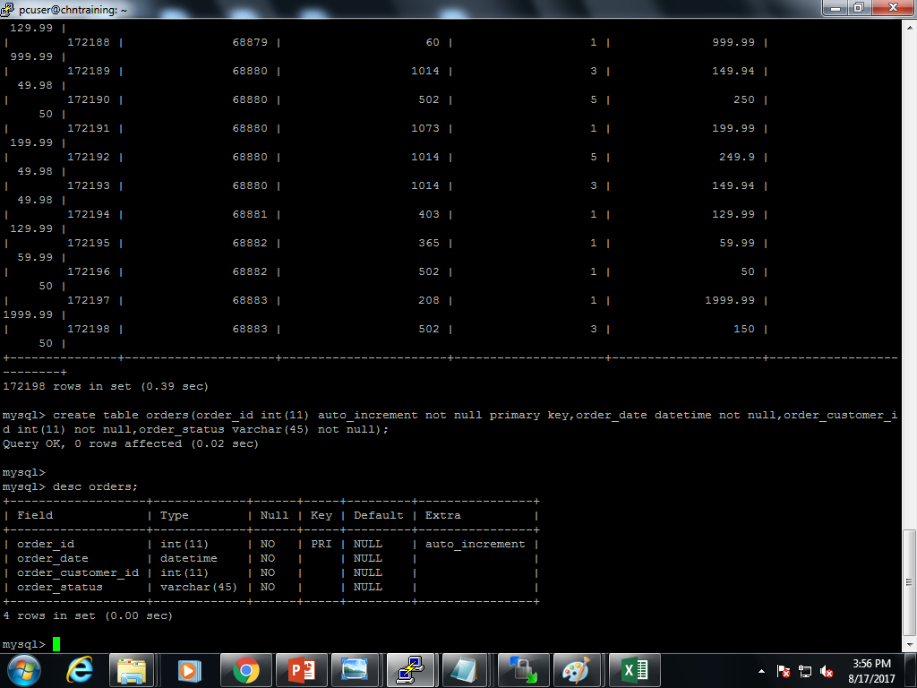

>load data local infile '/home/pcuser/surya/project/orders.csv' into table surya_project.orders fields terminated by ',' lines terminated by '\n'; 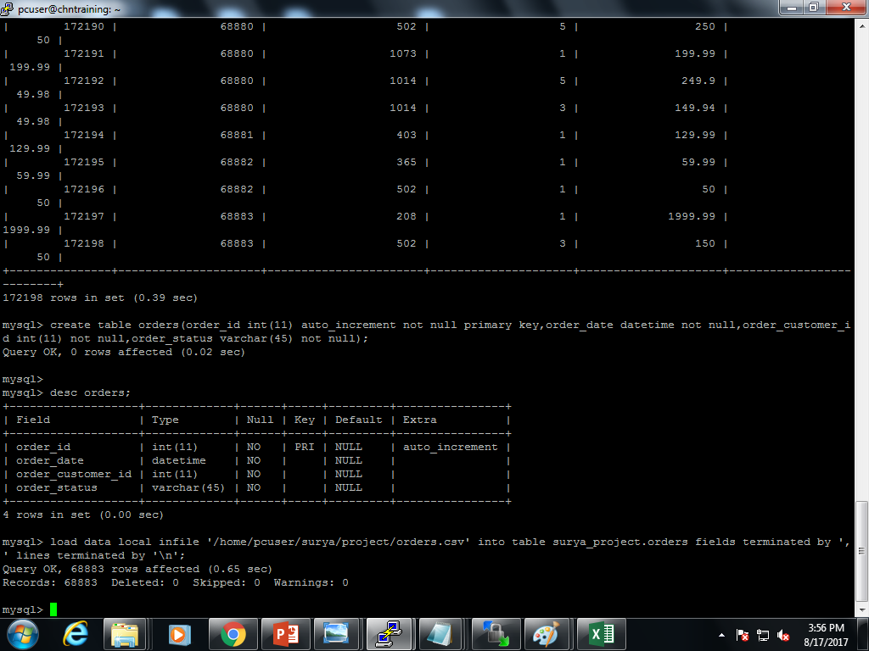

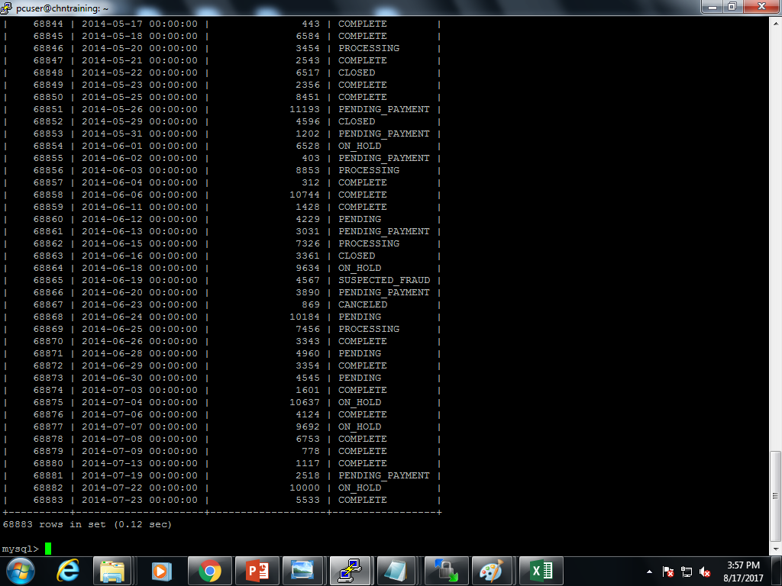

>select * from order;

4) >create table order_items(order_item_id int(11) auto_increment not null primary key,order_item_order_id int(11) not null,order_item_product_id int(11) not null,order_item_quantity tinyint(4) not null,order_item_subtotal float not null,order_item_product_price float not null); 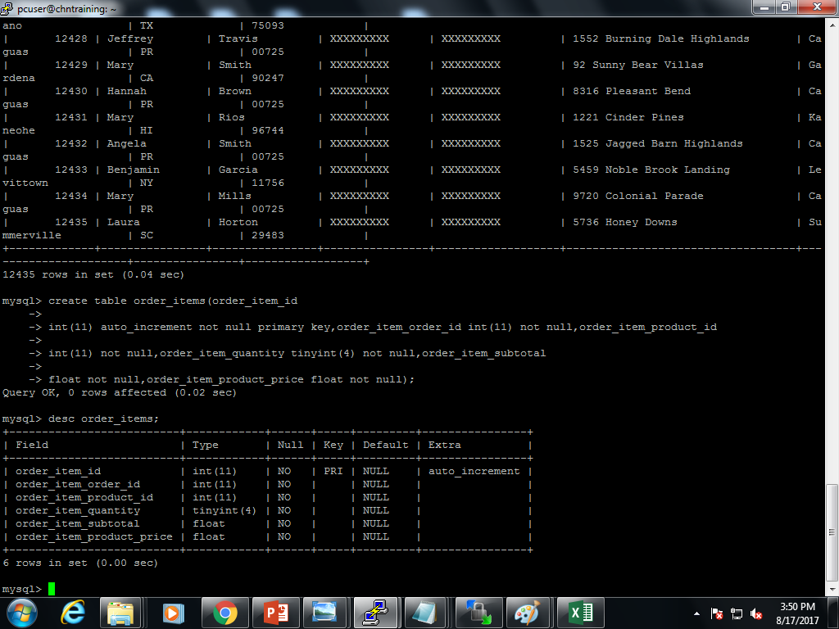

>load data local infile '/home/pcuser/surya/project/order_items.csv' into table surya_project.order_items fields terminated by ',' lines terminated by '\n';

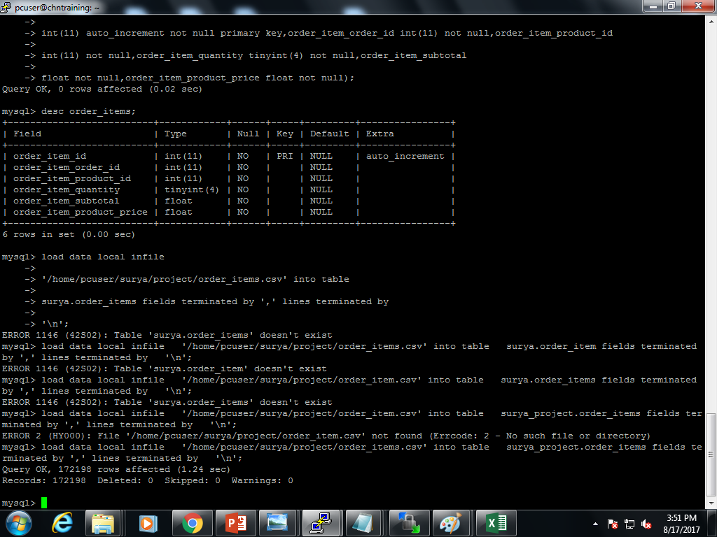

>select * from order_items;

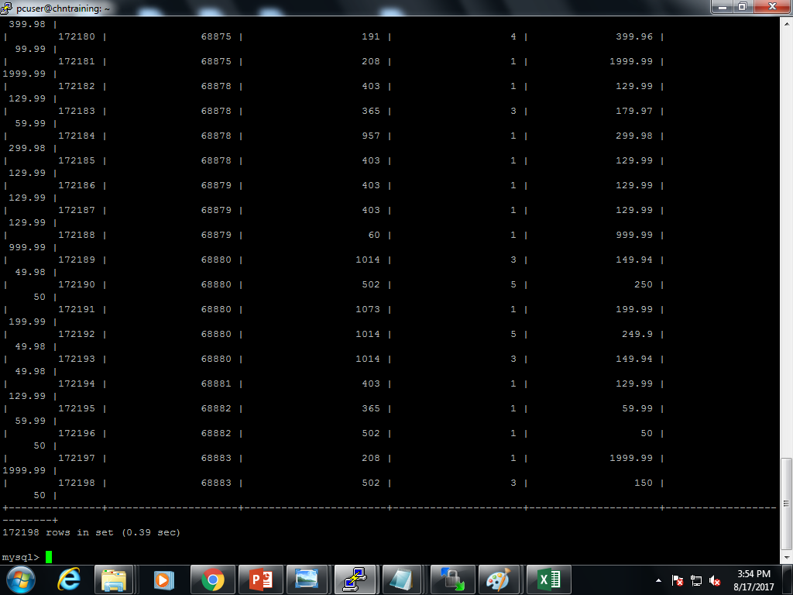

5) >create table departments (department_id int(11) auto_increment not null primary key,department_name varchar(45) not null);

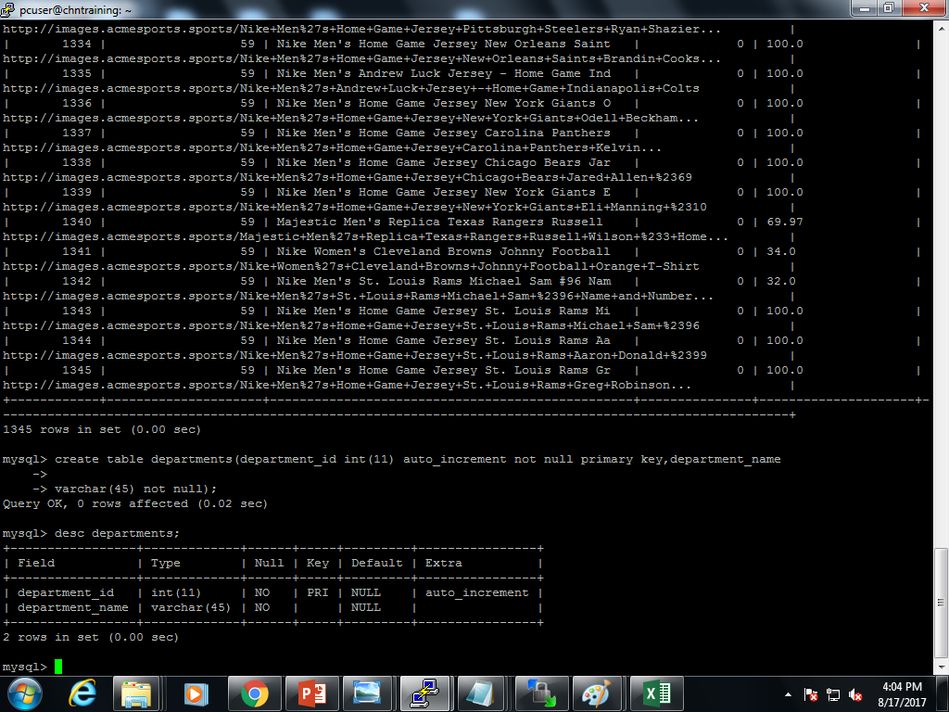

>load data local infile '/home/pcuser/surya/project/departments.csv' into table surya_project.departments fields terminated by ',' lines terminated by '\n';

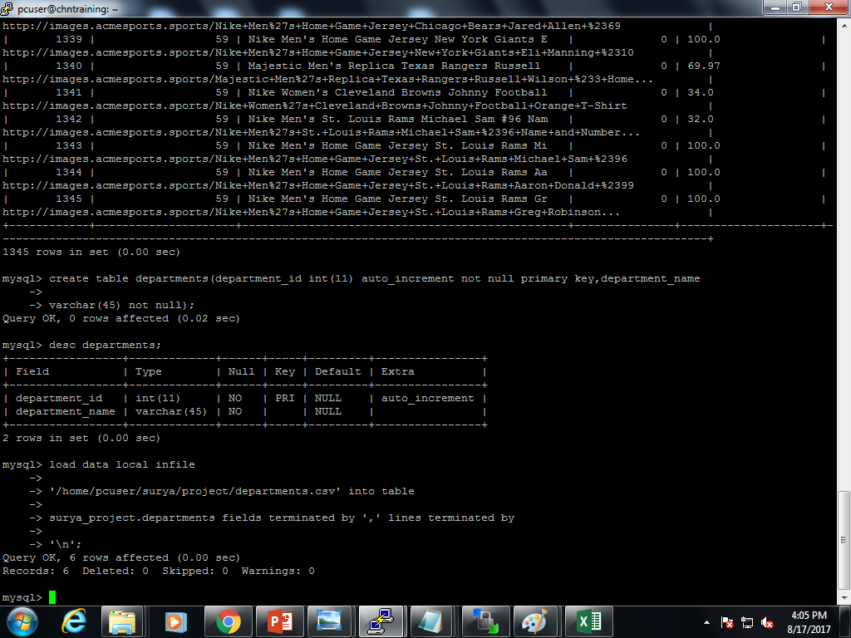

>select * from departments;

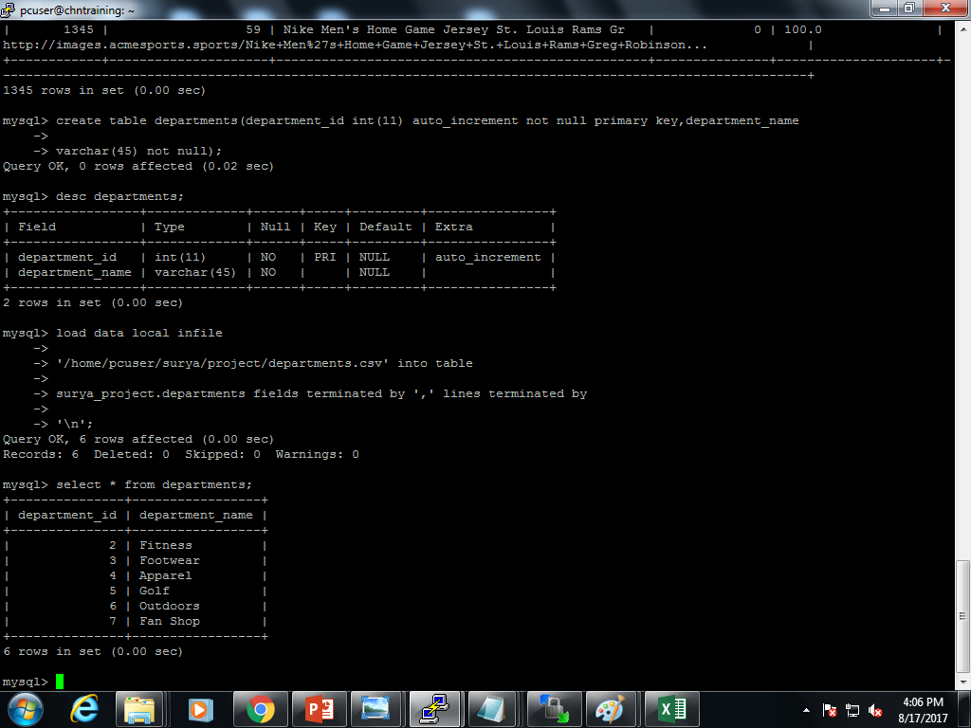

6) >create table products(product_id int(11) auto_increment not null primary key,product_category_id int(11) not null,product_name varchar(45) not null,product_description varchar(255) not null,product_price float not null,product_image varchar(255) not null);

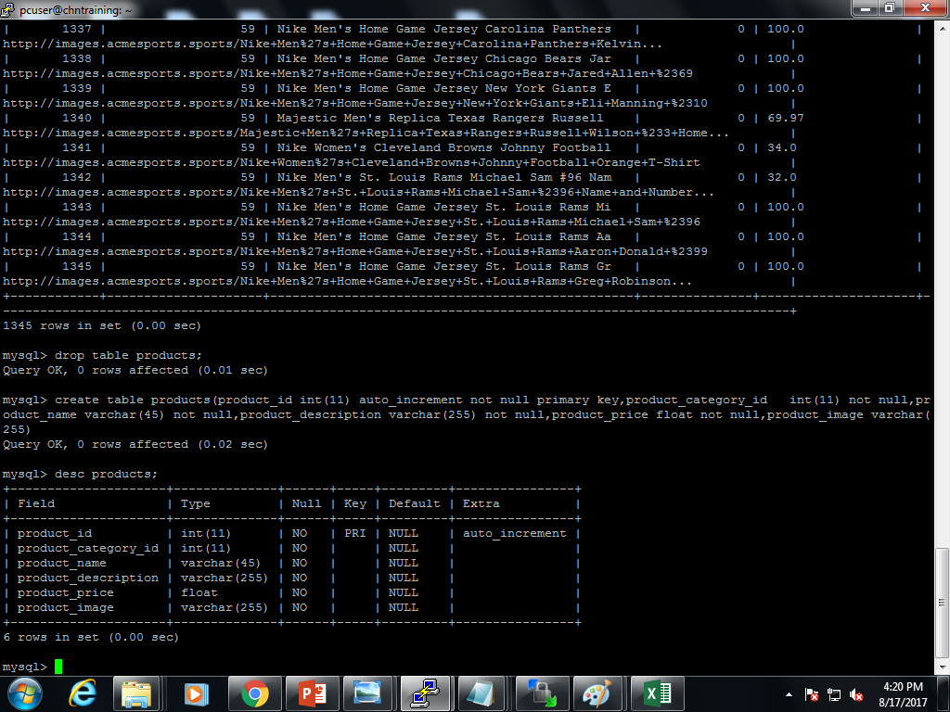

>load data local infile '/home/pcuser/surya/project/products.csv' into table surya_project.products fields terminated by ',' lines terminated by '\n';

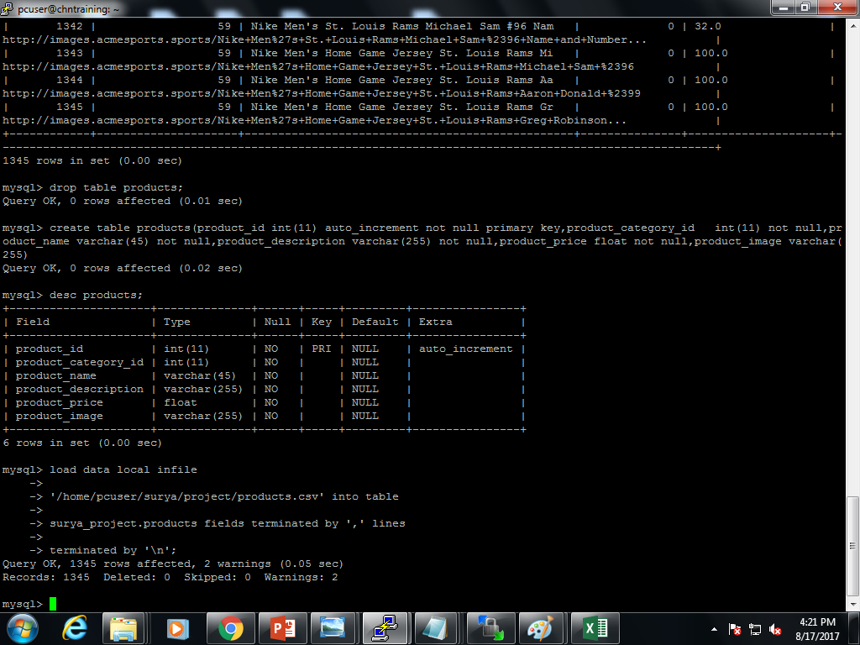

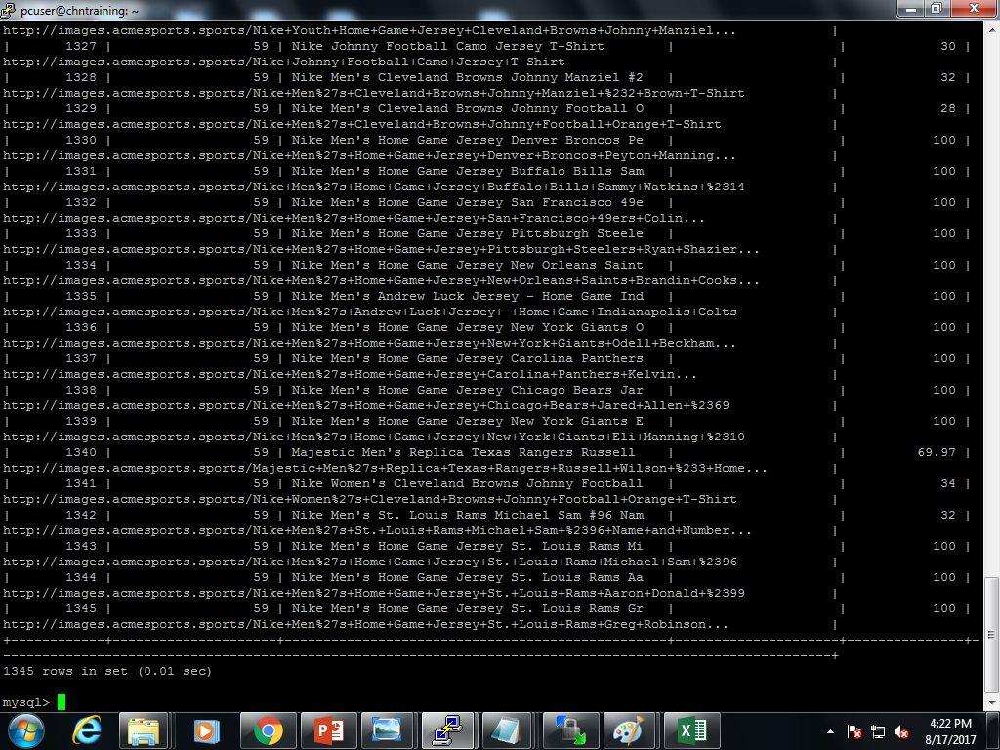>Select * from products;

**HIVE**

>hive

>show databases;

>use surya_project;

//after importing tables from sqoop

>select * from customers;

>select * from category;

***Loading the data from mysql to hive:***

1)sqoop bin$>sqoop import --connect jdbc:mysql://localhost/surya_project --username root --password root --table customers --hive-import --hive-table surya_project.customers -m 1;

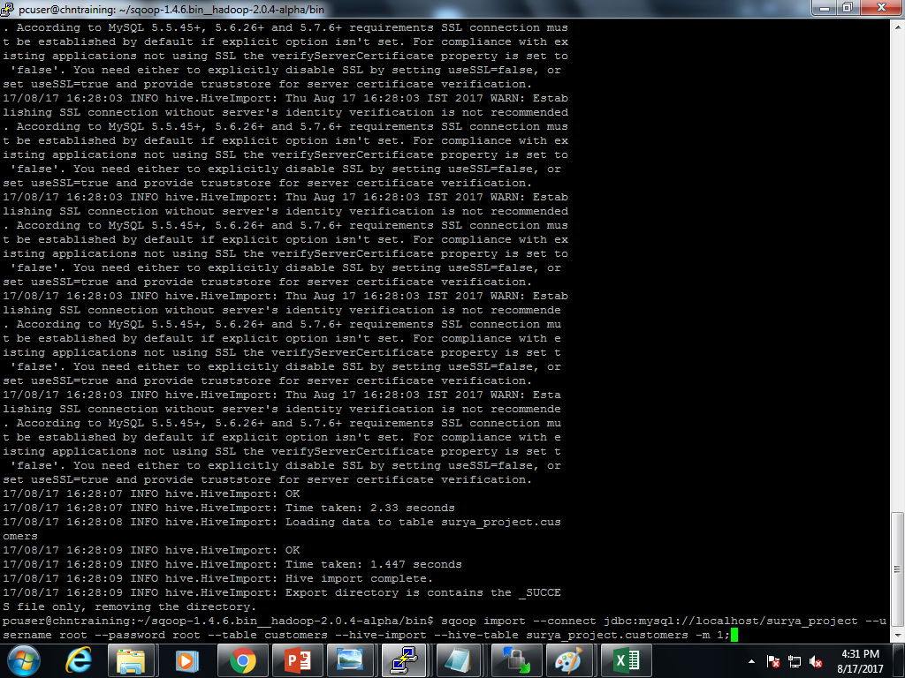

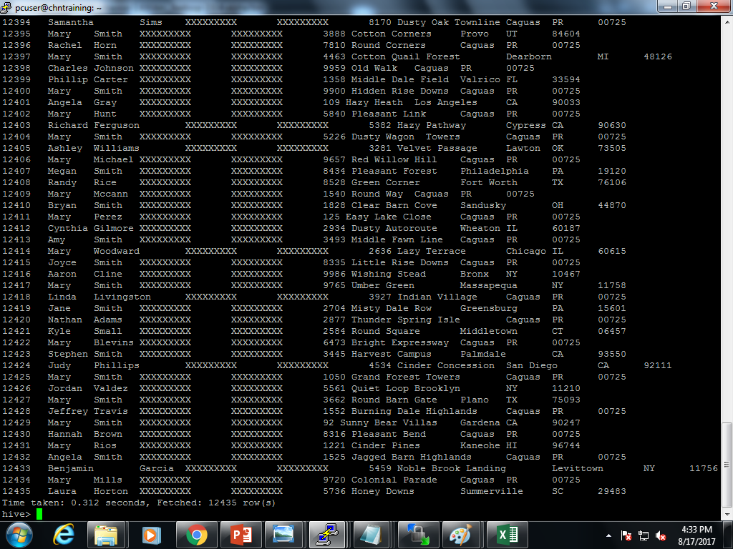

2)sqoop bin$>sqoop import --connect jdbc:mysql://localhost/surya_project --username root --password root --table category --hive-import --hive-table surya_project.category -m 1;

//username is set as root.

//password is set as root.

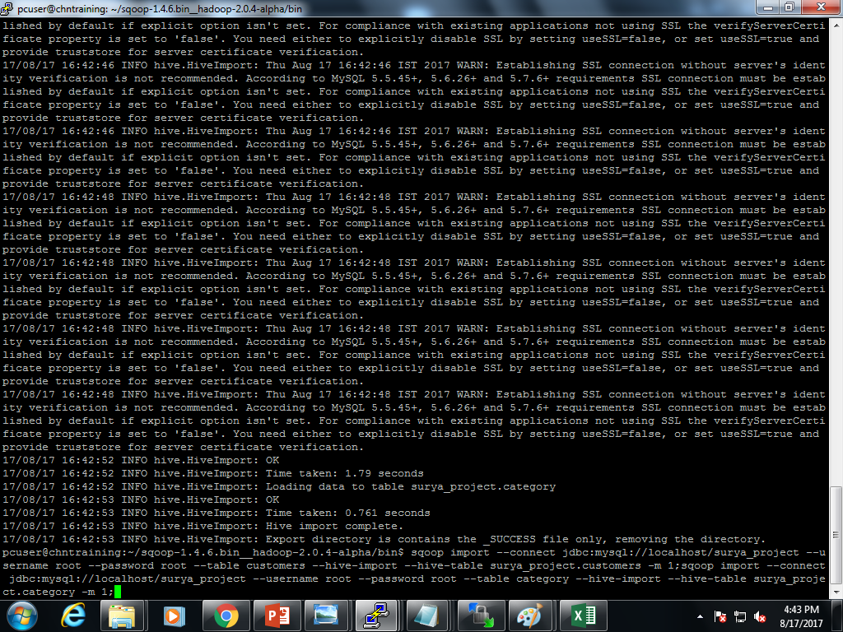

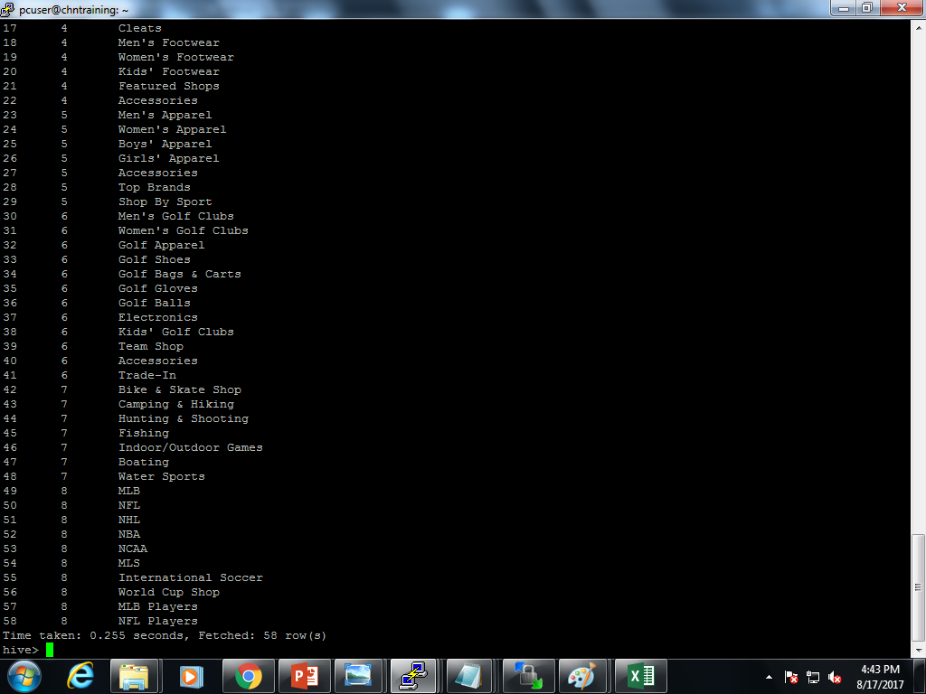

3)sqoop bin$>sqoop import --connect jdbc:mysql://localhost/surya_project --username root --password root --table departments --hive-import --hive-table surya_project.departments -m 1;

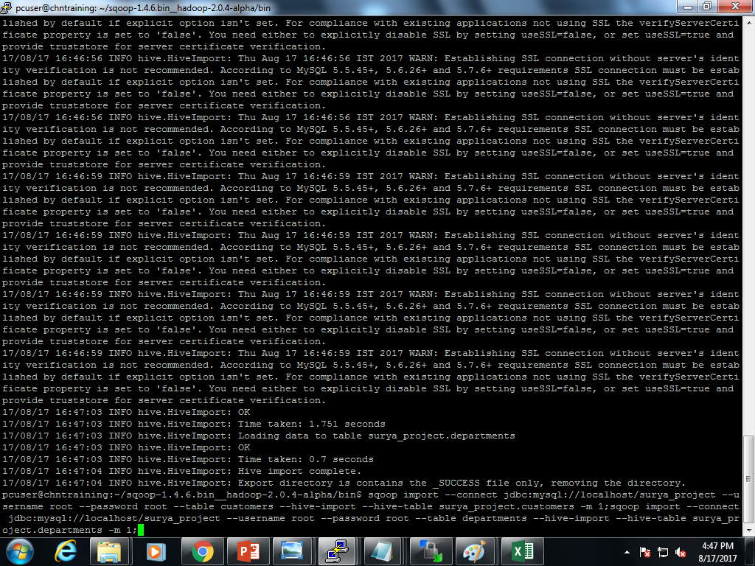

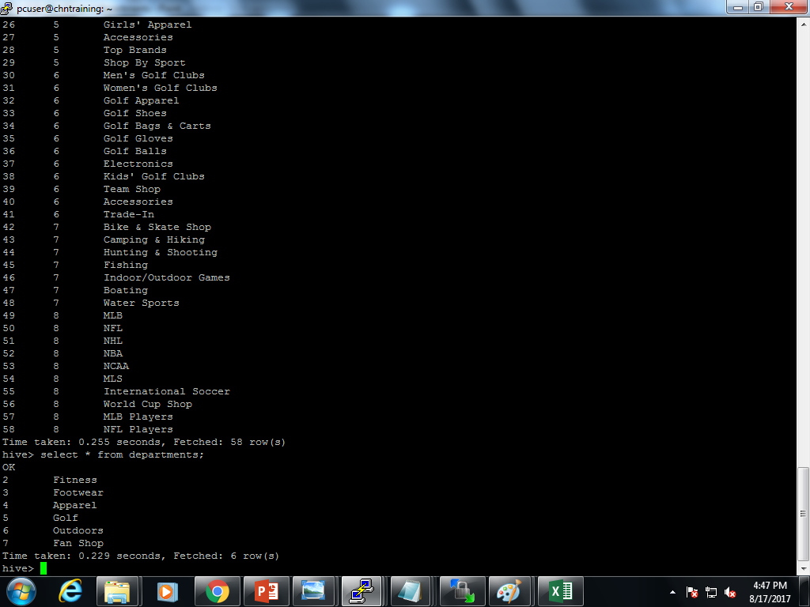

4)sqoop bin$>sqoop import --connect jdbc:mysql://localhost/surya_project --username root --password root --table order_items --hive-import --hive-table surya_project.order_items -m 1;

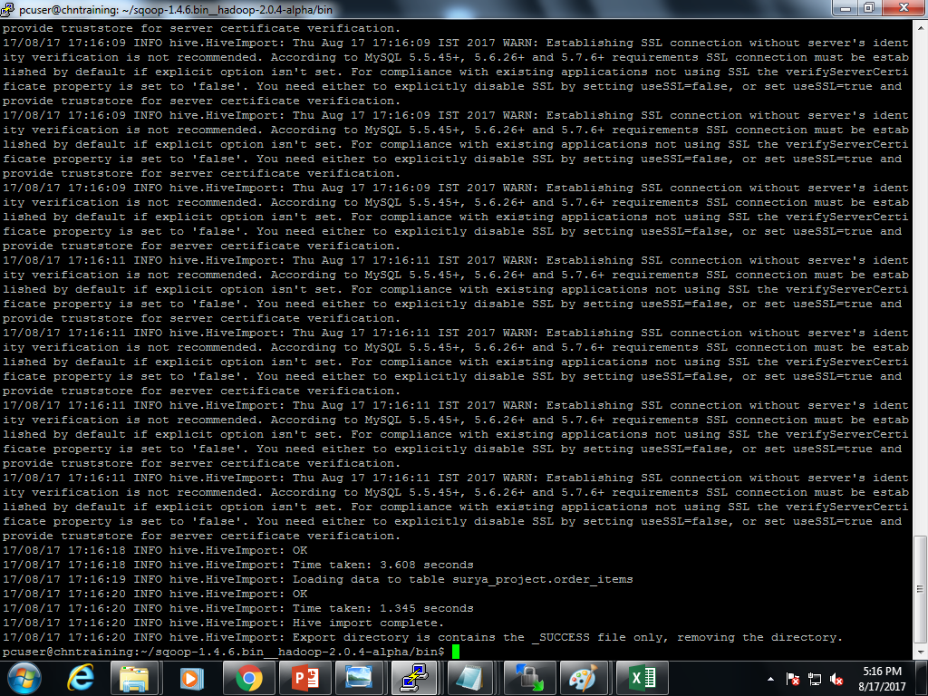

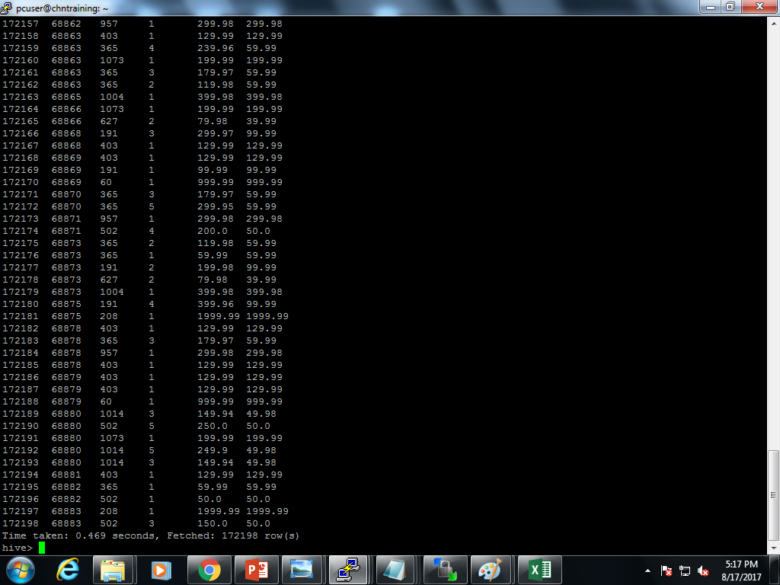

5)sqoop bin$>sqoop import --connect jdbc:mysql://localhost/surya_project --username root --password root --table orders --hive-import --hive-table surya_project.orders -m 1;

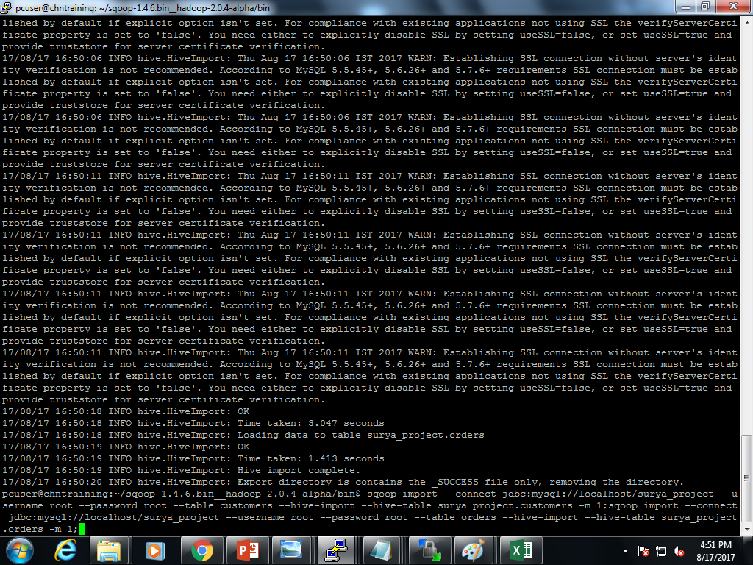

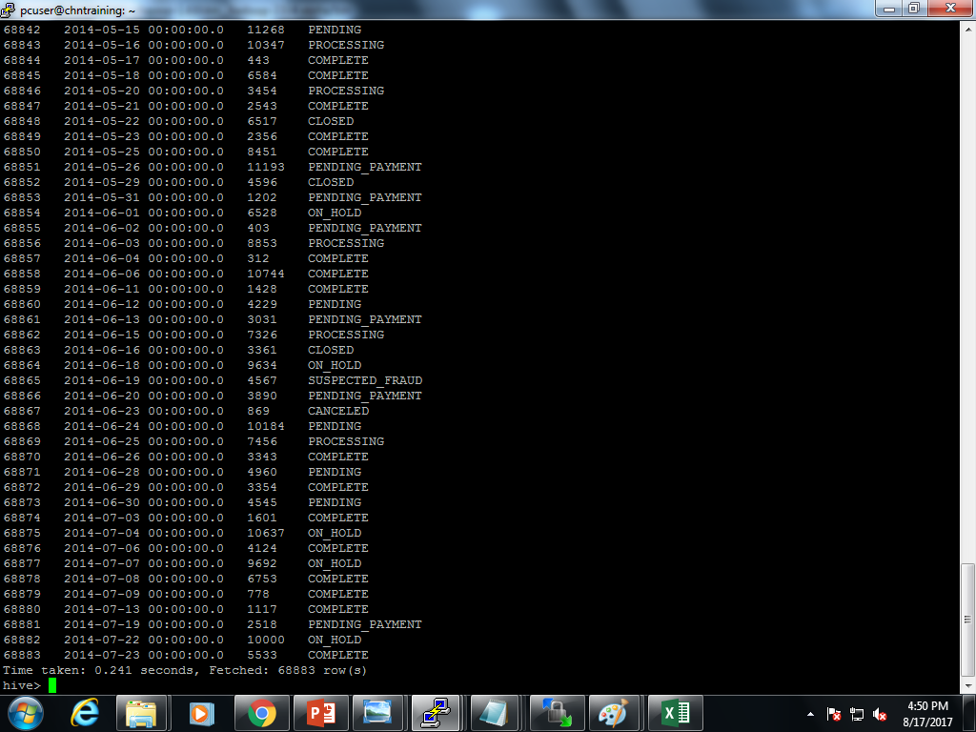

6)sqoop bin$>sqoop import --connect jdbc:mysql://localhost/surya_project --username root --password root --table products --hive-import --hive-table surya_project.products -m 1;

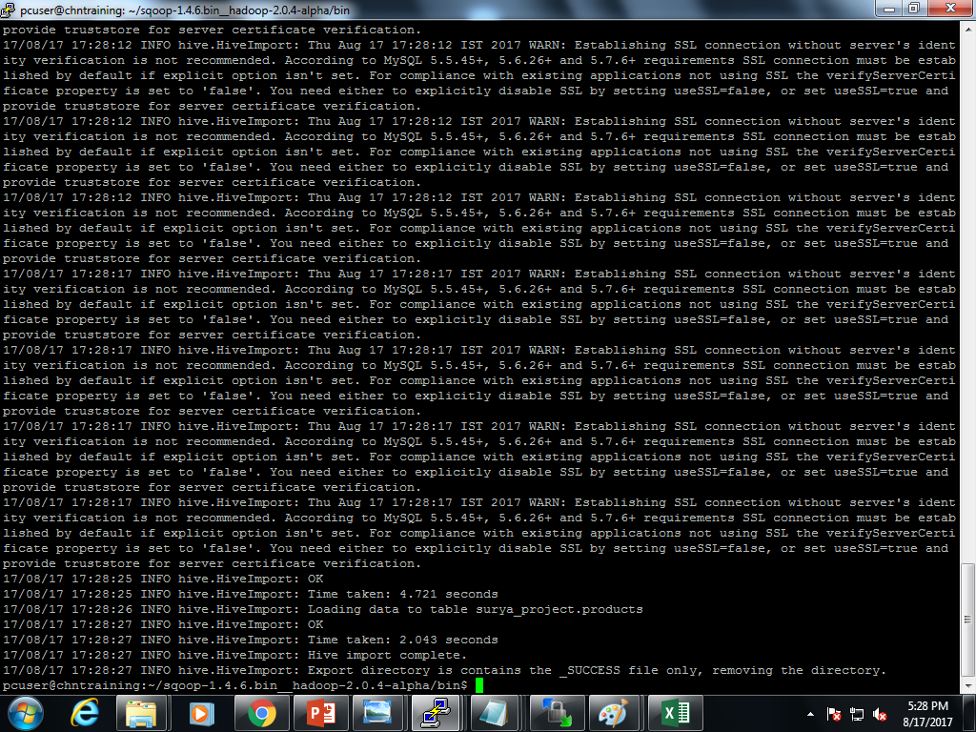

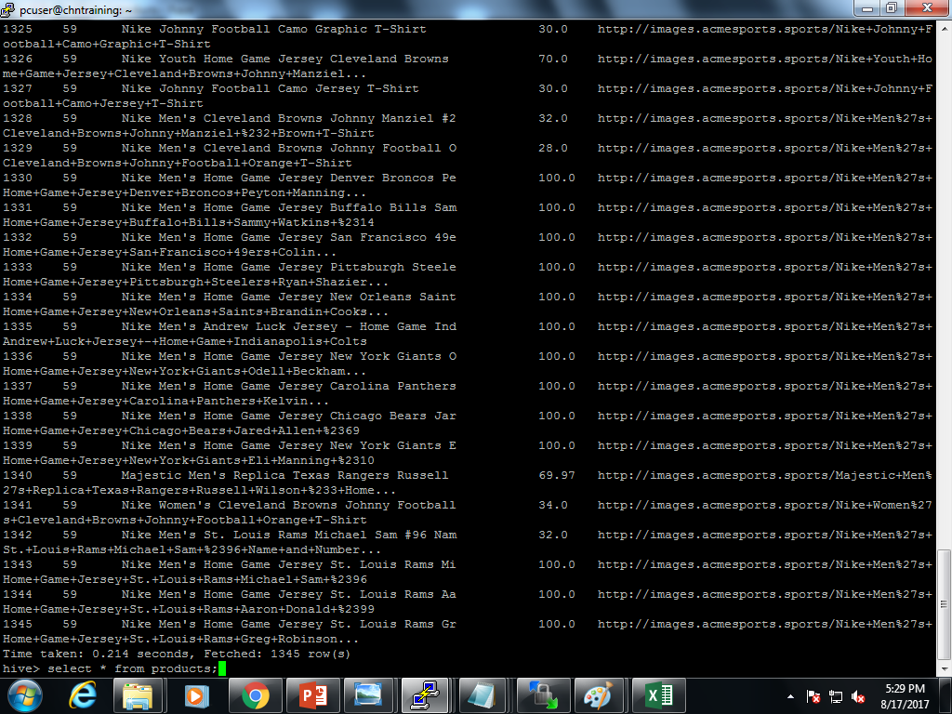

**Hdfs OUTPUT:** **/user/hive/warehouse/surya_project.db**

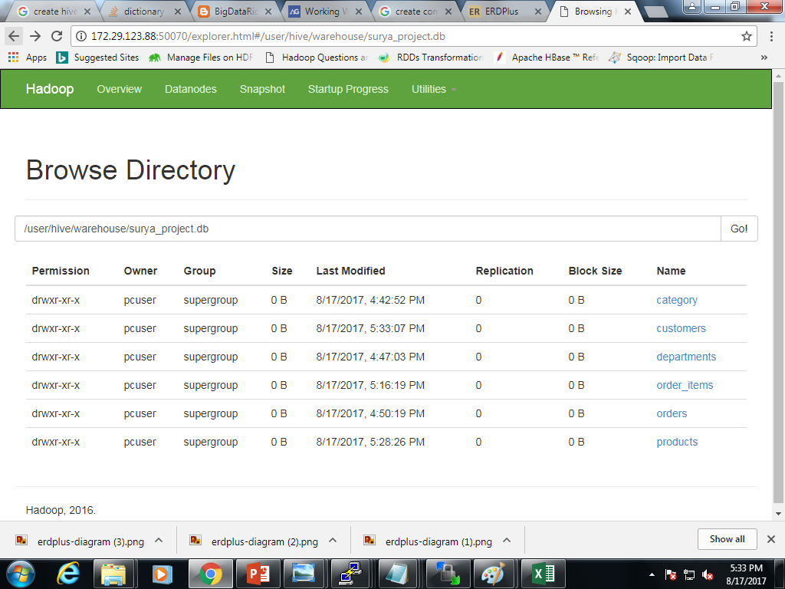

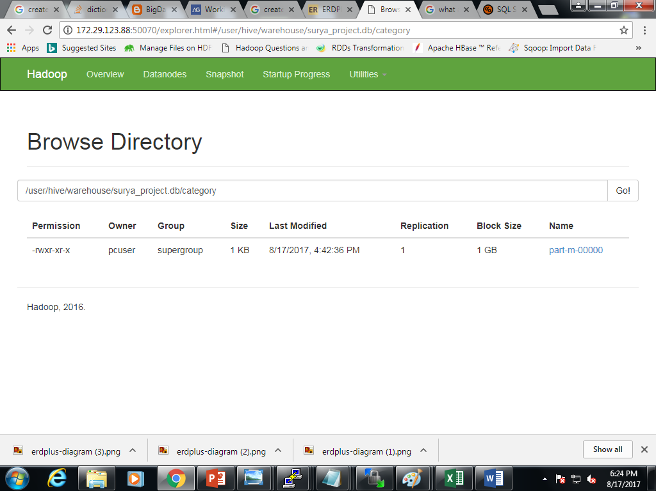

**Category output file.**

**PARTITIONING**

**//to set dynamic partitioning.**

**//default:hive partitioning is static**

>SET hive.exec.dynamic.partition=true;

>SET hive.exec.dynamic.partition.mode = nonstrict;

**1)>**create table add (customer_id int,customer_name string,customer_lname string,customer_fname string,customer_email string,customer_password string,customer_street string,customer_city string,customer_zipcode string) partitioned by (customer_state string);

>insert overwrite table add partition(customer_state='ca') select customer_id,customer_name,customer_lname,customer_fname,customer_email,customer_password,customer_street,customer_city,customer_zipcode from customers where customer_state = 'ca';

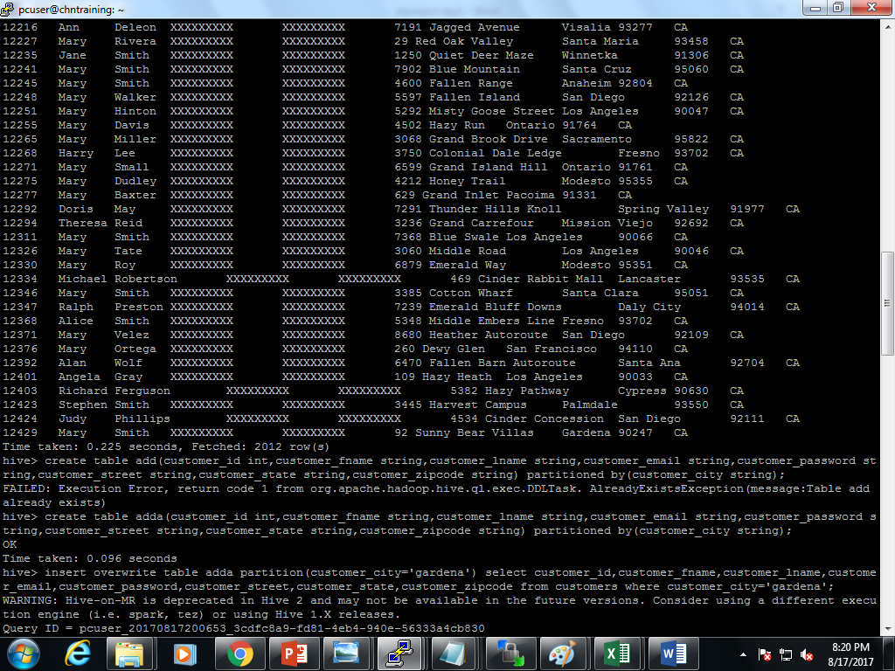

**2)>**create table dk (customer_id int,customer_name string,customer_lname string,customer_fname string,customer_email string,customer_password string,customer_street string,customer_state string,customer_zipcode string) partitioned by (customer_city string);

>insert overwrite table dk partition (customer_state='Gardena') select customer_id,customer_name,customer_lname,customer_fname,customer_email,customer_password,customer_street,customer_city,customer_zipcode from customers where customer_city = 'Gardena';

Select * from dk;

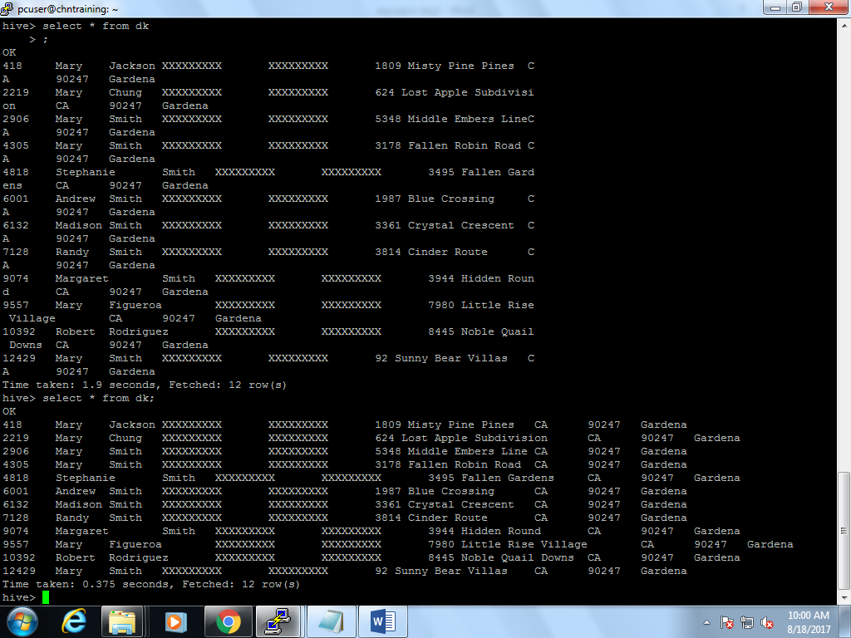

**GROUP BY**

select customer_state,count(customer_id) from customers group by customer_state;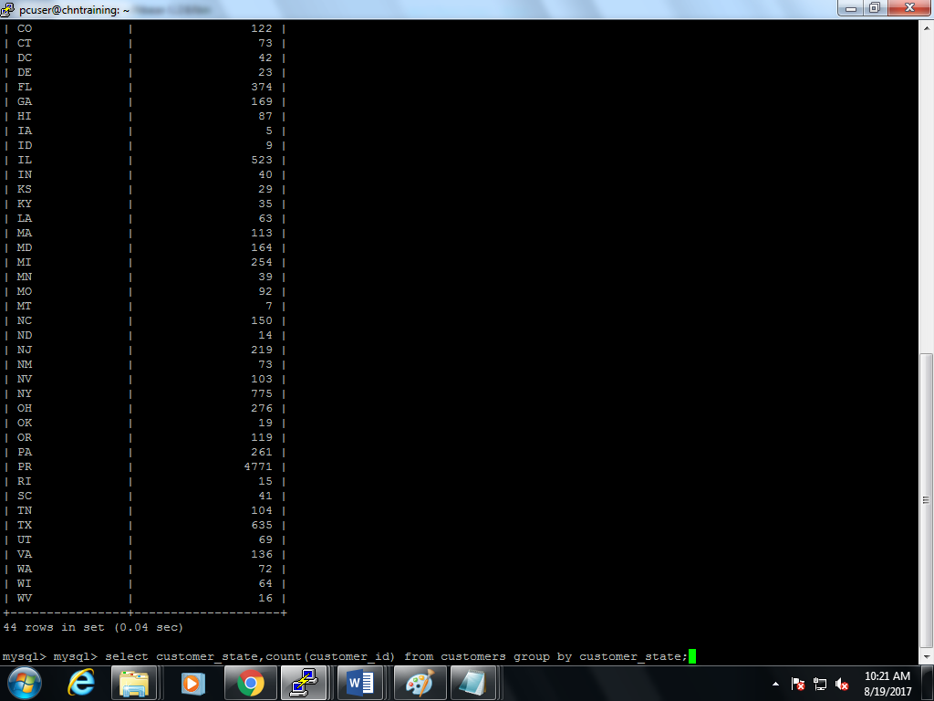

Top five customer:

SELECT customer_fname,customer_lname, customer_id,sum(product_price) as amount_purchased FROM hnew GROUP BY customer_fname,customer_lname, customer_id order by sum(product_price) desc limit 5;

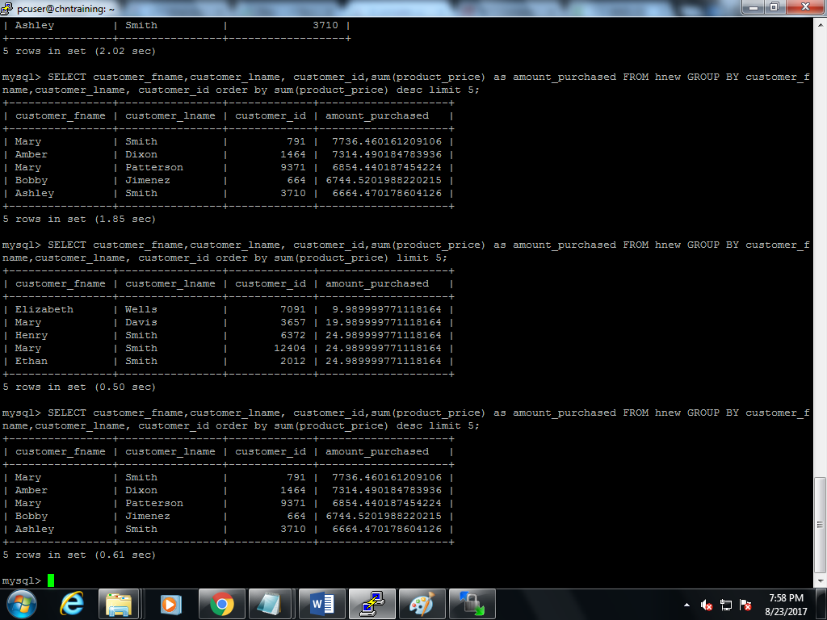

**BUCKETING**

set hive.enforce.bucketing =true;

1. create table bucket_orders1(order_id int,order_date string, order_customer_id string,order_status string) row format delimited fields terminated by ',' stored as textfile;
2. load data local inpath '/home/pcuser/surya/project/orders.csv' into table bucket_orders1;
3. create table bucket_orders(order_id int,order_date string, order_customer_id string) partitioned by (order_status string) clustered by (order_customer_id) into 4 buckets;
4. insert overwrite table bucket_orders partition(order_status) select * from bucket_orders1;

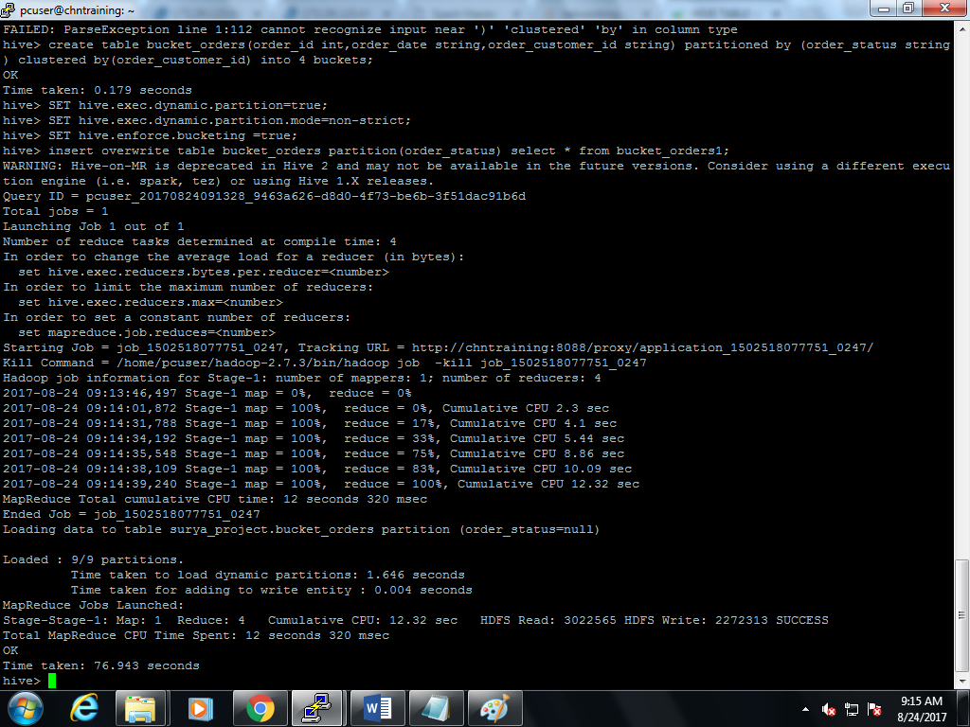

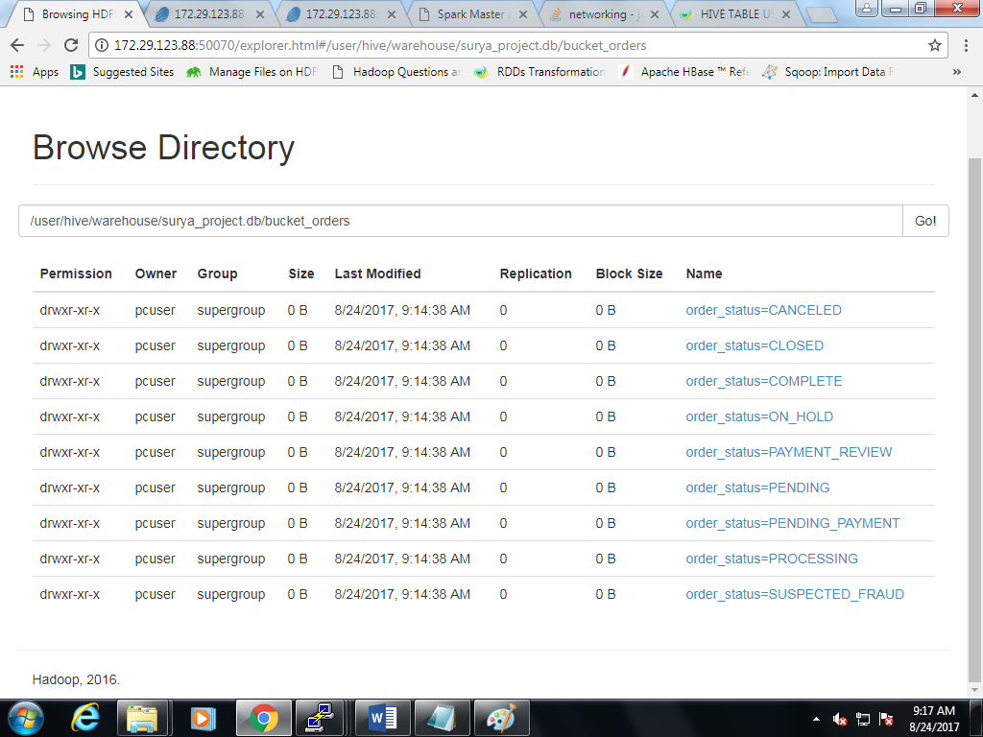

1. hadoop fs -ls /user/hive/warehouse/surya_project.db/bucket_orders;

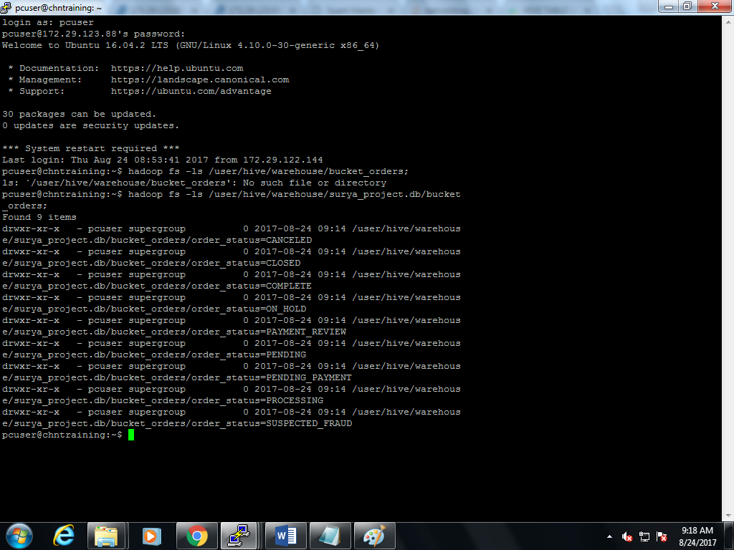

1. hadoop fs –ls /user/hive/warehouse/surya_project.db/bucket_orders/order_status=completed;

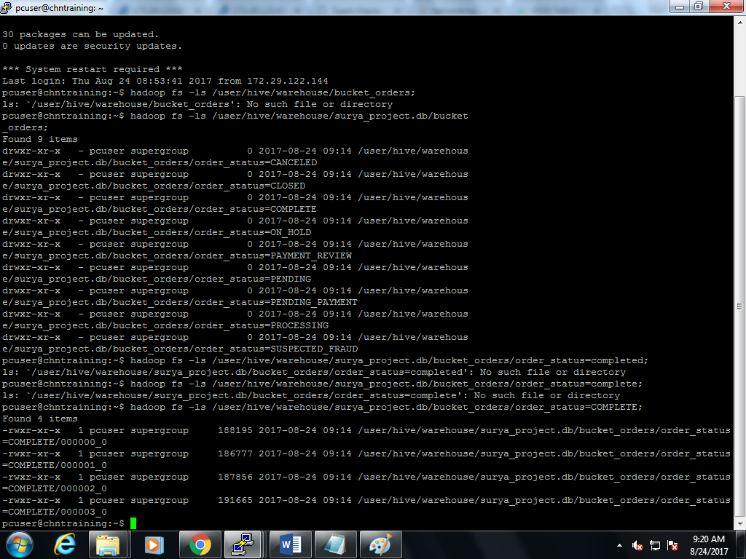

1. select * from bucket_orders TABLESAMPLE(BUCKET 1 OUT OF 4 ON order_status);

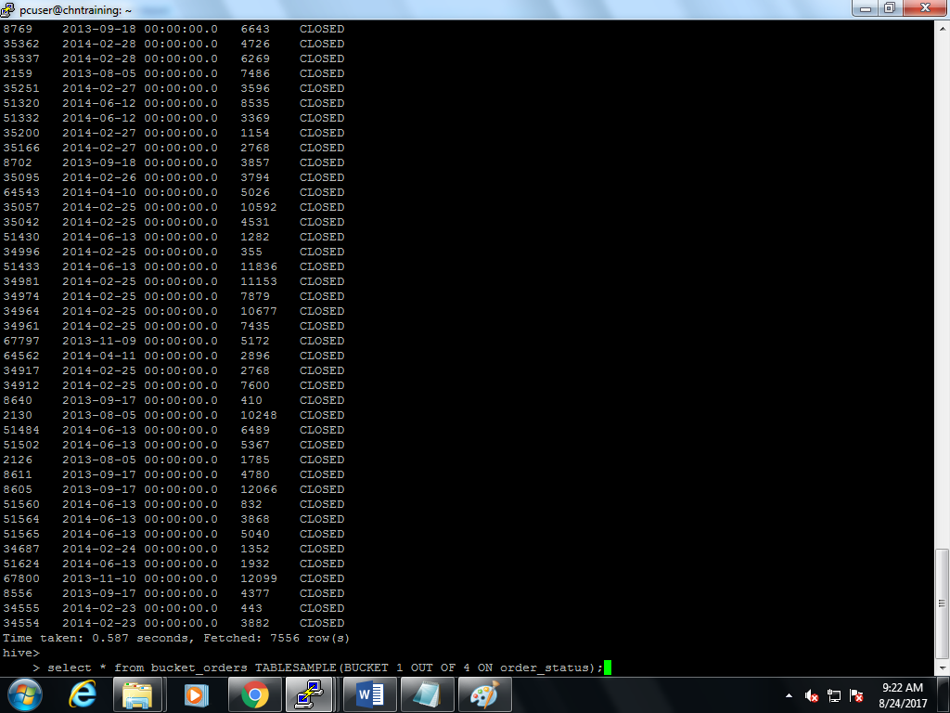

1. select * from bucket_orders TABLESAMPLE(BUCKET 2 OUT OF 4 ON order_status);

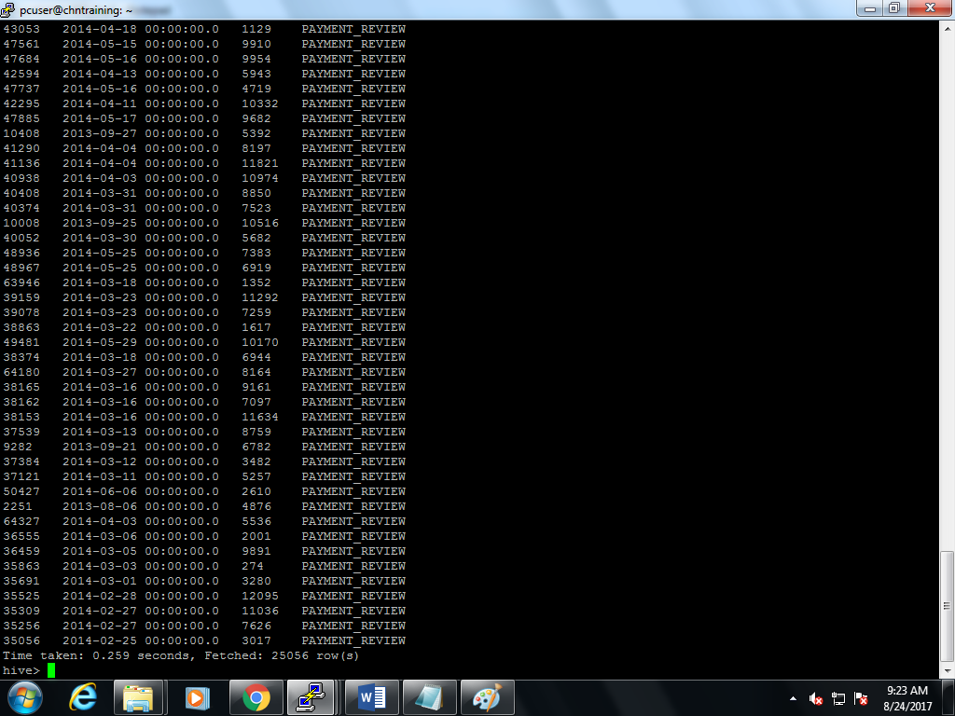

1. select * from bucket_orders TABLESAMPLE(BUCKET 3 OUT OF 4 ON order_status);

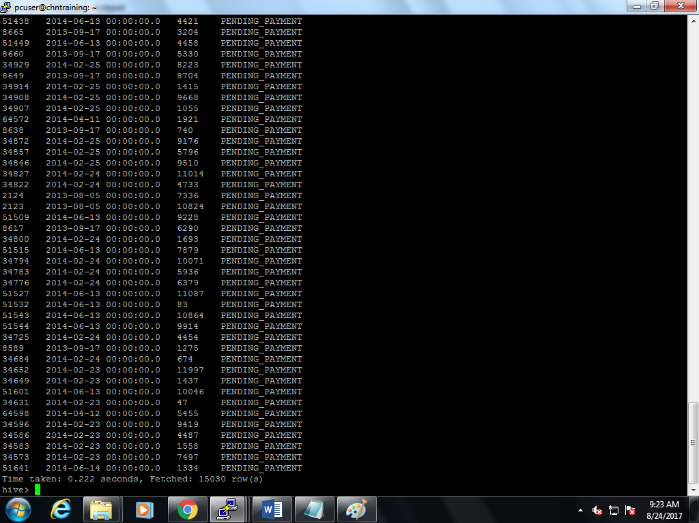

1. select * from bucket_orders TABLESAMPLE(BUCKET 4 OUT OF 4 ON order_status);

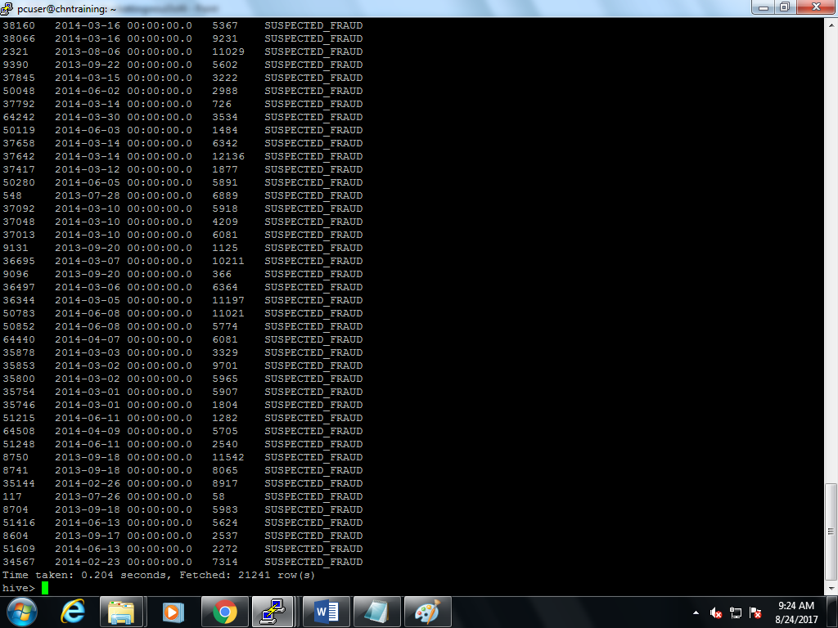

**Top 5 products:**

Select product_name,product_price,order_item_quantity from hnew group by prouct_name,product_price,order_item_quantity order by order_item_quantity desc limit 5;

**Based on quantity:**

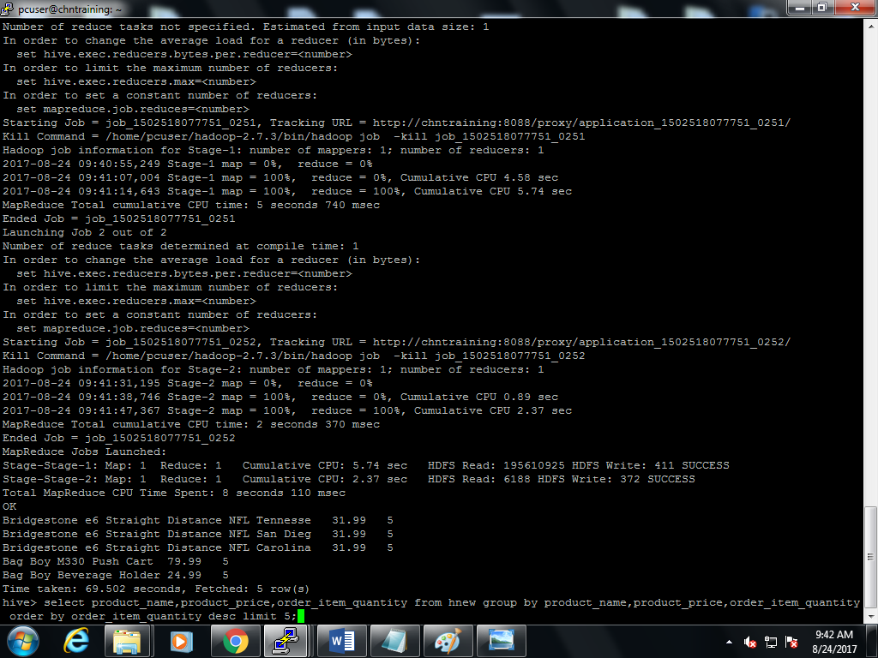

**Based on price:**

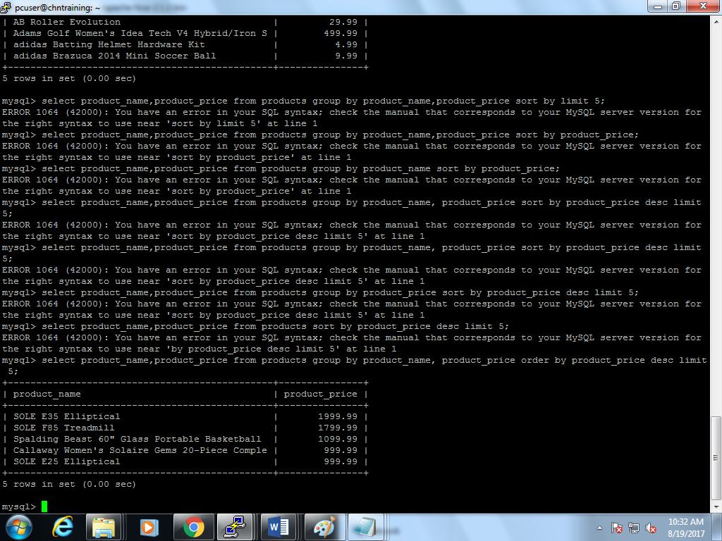

**Top 5 orders based on date:**

**Select product_name,product_price,order_item_quantity,order_date from hnew group by product_name,product_price,order_item_quantity,order_date order by order_date desc limit 5;**

